Nama : Faiz Noor Adhytia
NIM : 22.K3.0006
Image Interpolation

- The Artifact Hunt
1.1. The most stair-stepping or blockiness.
The Nearest Neighbor is a “stair-stepping” method. This is due to diagonal or curved edges, nearest neighbor simply copies the nearest pixel without blending, causing sharp “steps” instead of smooth transition.
1.2. The Smoothest Areas
Bilinear is the most Mushy in smooth areas such as the sky tone. This is due to this method is averaging the colors of nearby pixels, which smooths gradient but also reduces texture and sharpness. Areas that should have slight tonal variation may look overly soft or “mushy”.
1.3. The Ringing Artefact
Bicubic appear slightly sharper than in the original. However, this extra sharpness can introduce faint ringing artifacts, both light or dark halos can appear caused by overshooting around high contrast edges
- Performance Profiling
2.1. Image Interpolation Execution Time Comparisons.
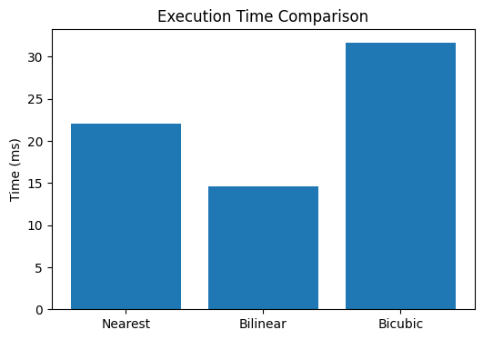
Figure 1. Execution Time Comparison between Nearest, Bilinear, and Bicubic

2.2. The Smoothest Areas
Bicubic percentage differentiation is calculate with equation below, in Equation (1):
$$\frac{T_{Bicubic}-T_{bilinear}}{T_{Bilinear}}×100\%$$ | (1)
By using the equation, the percentage difference is 117.37% slower than Bilinear. Explained in Equation (2):
$$\frac{{65.43}_{}-{30.11}_{}}{30.11}×100\% = 117.37\%$$ | (2)

2.3. Relationship Between Number Pixels Each Algorithm Samples
The more pixels each interpolation method samples, the higher its computational cost. This results in smoother and sharper results but at the expense of processing time. In real-time applications, Bilinear often offers the best balance between speed and quality.

Table 1. Relationship Between Sampled Pixels and Processing Time
Interpolation Method | Pixels Samples | Computation Complexity | Processing Time | Visual Quality
Nearest Neighbor | 1 | Very Low | Fastest | Lowest
Bilinear | 4 | Moderate | Medium | Moderate
Bicubic | 16 | High | Slowest | Highest

